COMP90007 Internet Technologies
Project 1 – Network Analysis
Student Name: Guancheng Rong
Canvas Login Username: Guancheng R
Student ID: 1856981

Section 2
Ans 2.1
Looking at Fig 2.1.1 and the result achieved in section 2 of the appendix Fig2.1.2

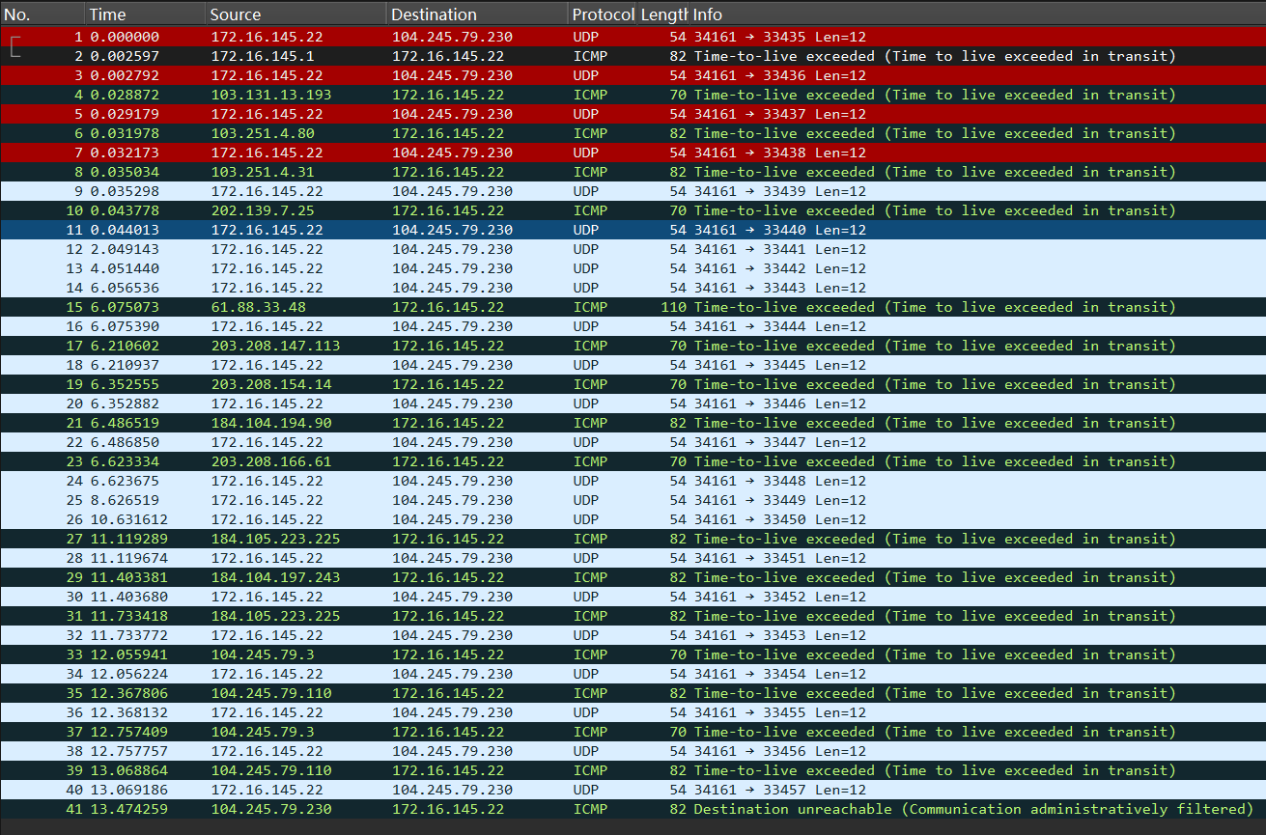
<Fig 2.1.1 Wireshark for one packet from my apartment to speedtest.awbb.net>

Traceroute probes the network path hop-by-hop by sending serialized UDP or ICMP messages with incrementing TTLs to the destination host. It uses the ICMP timeout messages returned by the router when the TTL expires to record the IP address and round-trip delay of each hop.
Therefore, we could use Wireshark to return ICMP protocol to obtain every hop’s IP address. We also can get IP addresses directly from terminal.
My Wireshark capture filter is icmp or (udp and portrange 33434-33534). The first part, ICMP, captures all ICMP protocol packets—this corresponds to the ICMP Time Exceeded message returned by the router during traceroute and the ICMP Destination Unreachable message returned by the final destination. Part 2, UDP and portrange 33434-33534, captures UDP packets on target ports in the range of 33434 to 33534 which is meaning that the maximum of the hops is 100. They are sent to the target host in UDP protocol, with the destination port increasing hop by hop starting from 33434.

Will this filter capture non-traceroute traffic?
Yes. The ICMP part is quite broad—it captures not only traceroute-related ICMP Time Exceeded and Destination Unreachable errors, but also any other ICMP traffic. For example, if the user were pinging google.com while capturing packets, those ping ICMP packets will also be captured by this filter.
Similarly, for the UDP and port range 33434-33534, if other applications happen to use UDP communication within this port range.

From the Fig2.1, there are some information about the first 5 hops and last hop.
1st 172.16.145.1 TTL (Time-to-live exceed) = 1
2nd 103.131.13.193 TTL = 2
3rd 103.251.4.80 TTL = 3
4th 103.251.4.31 TTL = 4
5th 202.139.7.25 TTL = 5
The last 104.245.79.230
We will analyse the 6 hops line by line.
The first hop is 172.16.145.1. It shows that the packet was sent to the private network gateway which is the student apartment IP address.
The second hop is 103.131.13.193. According to section 2 of the appendix Fig2.1.3, We could search from https://db-ip.com/ and find it belongs to Melbourne, [1] which maybe Metropolitan Area Network. This time’s RTT is high up to 26.332ms, which is meaning that the packet was transmitted to the local central network gateway.
The third hop is 103.251.4.80. According to section 2 of the appendix Fig2.1.4, We could search from https://db-ip.com/ and find it belongs to Sydney.[1] Meanwhile, the RTT is quite low which is meaning that we still send messages to the Australia network gateway.
The forth hop is 103.251.4.31. According to section 2 of the appendix Fig2.1.5, We could search from https://db-ip.com/ and find it belongs to Sydney. [1] Similarly, the RTT indicates that we still send messages to the Australia network gateway. Meanwhile, the IP address there is a difference only in the last byte, which is meaning that both belong to one ISP.
The fifth hop is 202.139.7.25. According to section 2 of the appendix Fig2.1.6, We could search from https://db-ip.com/ and find it belongs to Sydney. [1] However, in this case, the RTT suddenly increased significantly from 3ms to 8ms, which may mean the network is preparing for the internation transmission. The packet arrived at the peering point. Then, the following traceroute, there are 3 following hops exceed time which is also proving that the result.
In summary, until the fifth hop, all RTT is under 9ms, which is low compared with the future RTT. We could know until now that we still send the ICMP messages in Australia.
The last hop is 104.245.79.230. We can see it in Wireshark. There is one info which shows Destination unreachable. This meaning our request has reach the destination. No matter whether it’s reachable or not, it’s the IP address of speedtest.awbb.net. According to RTT number, we could easily know we sent the ICMP message to one internation network gateway.

Ans 2.2
It continues section 2 of the appendix Fig 2.2.4~Fig 2.2.13[1]
I choose the iperf.he.net as the 10th severer which is in California, USA.
We could get the latitude and longitude of the ten severer. And there are some interesting finds. Firstly, the third severer (speedtest.wobcom.de) in Austria is actual in Germany [1] and in the same city which has 2nd severer (spd-desrv.hostkey.com). Then, the 7th severer is listed in Porto, Portugal, but it locates in Lisbon in fact. [1] The last some severer can’t use UDP traceroute mode, therefore ICMP traceroute mode is an available alternative.

And then, I used one algorithm to calculate the distance between each severer and Melbourne. To calculate the great-circle distance between Melbourne and each destination were computed using the spherical law of cosines formulation of the Haversine distance (Sinnott, 1984), with a mean Earth radius of 6371.[2] According to Fig, destinations’ latitude and longitude come from the https://db-ip.com/. Depending on a python calculator – Fig 2.2.3 in appendix for section 2, we can get the result of the distance.
The distance between two points on the Earth's surface (assumed spherical) is computed with the Haversine spherical law of cosines formula:[2]
d = R * arccos * (sin(φ₁) * sin(φ₂) + cos(φ₁) * cos(φ₂) * cos (λ₂ − λ₁))
φ₁, λ₁ | Latitude and longitude origin (Melbourne)
φ₂, λ₂ | Latitude and longitude destination
There is one interesting find that except the 10th severer I choose by myself, the farthest severer is 7th severer(porto.speedtest.net.zon.pt) and the closest severer is 8th severer(speedtest.masnet.ec). The two severer we will use in the section 4.

And make a summary -- Fig 2.2.1
<Fig 2.2.1 the summary for 10 iperf severer >

Therefore, we could use the table to make A scatter chart of the hop count versus the approximate geographical distance from Melbourne.

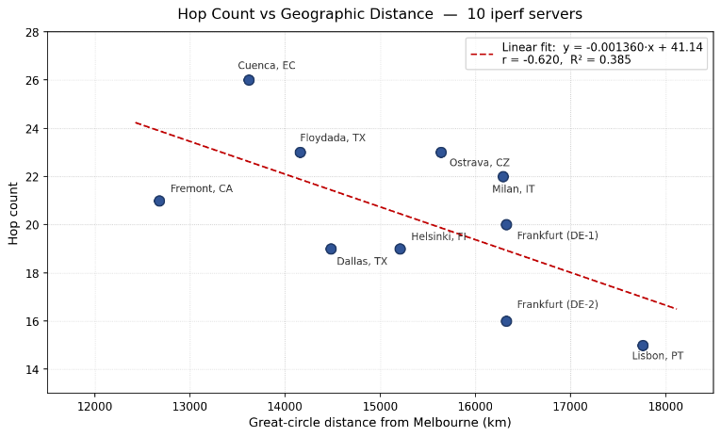
<Fig 2.2.2(a) A scatter chart of the hop count versus the approximate geographical distance from Melbourne >
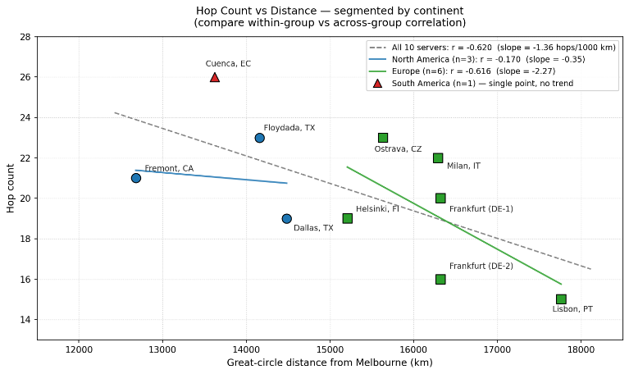
<Fig 2.2.2(b) A scatter chart by continent>
From Fig 2.2.2(a), we could easily find the R² = 0.385 and r = -0.620. The linear fit: y = -0.01360*x + 41.14. When the distance is increasing, the hop count is falling.
We could know the relationship between hop count and Geographic Distance is negative correlation.
There are two major reasons:
1. Long-distance routes often utilize large backbone networks. These backbone networks have high routing optimization and fewer hops. Short-distance routes, on the other hand, may involve peering through multiple smaller ISPs, increasing the hop count with each peering. For example, in your diagram, the distance between Cuenca and Ecuador is only ~13,500km, but the hop count is as high as 26, indicating that the route to South America passes through many intermediate networks.
2. We could know that Hop count reflects network topological distance, not geographical distance. Two geographically distant nodes directly connected by the same submarine fibre optic cable may have a low hop count; conversely, geographically close nodes that traverse multiple Autonomous Systems (AS) will have a high hop count. [3, p.396]
From Fig 2.2.2(b), when we divided the chart by continents, we could find that the six servers in Europe showed a strong negative correlation (r = -0.616), while the three servers in North America showed almost no correlation (r = -0.170). This indicates that the strength of the correlation depends on whether the routing paths share a similar backbone network structure.

Section 3
Ans 3.1

Looking at Fig 3.1.1 and the result achieved in section 3 of the appendix Fig 3.1.2
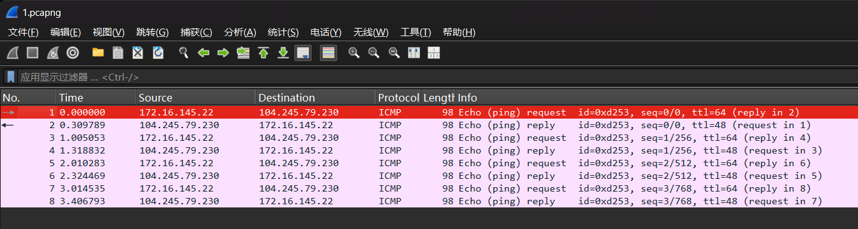
< Fig 3.1.1 Wireshark for ping speedtest.awbb.net>
Looking at Fig 3.1.1, my machine sends 4 ICMP echo request (type: Echo (ping) request (8), code: 0) to the destination, we could see them in the picture – No.1, No.3, No.5, No.7. The destination will send ping reply (type: Echo (ping) reply (0), code: 0). The original TTL is 64 and the reply TTL is 48, which is meaning that the packets burdens 64 – 48 = 16 hops. And we can see that all ICMP id is 0xd253 which indicates the 4 request and 4 reply belong to one time ping command.
Turn to Fig 3.1.2, the data bytes from speedtest.awbb.net is 56 bytes. However, each packet was transmitted 64 bytes, because ICMP header is 8 bytes which are included in the 64 bytes transition. And we could see the icmp_seq = 0/1/2/3[4] which is meaning for 4 ping packets from speedtest.awbb.net.
I used the icmp and host speedtest.awbb.net as the capture filter. It’s can capture other requests (non-ping related), such as traceroute speedtest.awbb.net.

Ans 3.2
Looking at Fig 3.2.1 ~ 3.2.10

<Place your figure Here>
Some more info about your analysis...

Ans 3.3 Looking at Fig <insert number> and the result achieved in section 3 of the appendix....
<Place your figure Here>
Some more info about your analysis...

Section 4
Ans 4.1 Looking at Fig <insert number> and the result achieved in section 4 of the appendix....
<Place your figure Here>
Some more info about your analysis...

Ans 4.2 Looking at Fig <insert number> and the result achieved in section 4 of the appendix....
<Place your figure Here>
Some more info about your analysis...

Ans 4.3 Looking at Fig <insert number> and the result achieved in section 4 of the appendix....
<Place your figure Here>
Some more info about your analysis...

Ans 4.4 Looking at Fig <insert number> and the result achieved in section 4 of the appendix....
<Place your figure Here>
Some more info about your analysis...

References
Use IEEE referencing scheme: https://library.unimelb.edu.au/recite/referencing-styles/ieee
[1] R. W. Sinnott, "Virtues of the Haversine," Sky and Telescope, vol. 68, no. 2, p. 159, 1984.
[2] db-ip.com, "IP Geolocation," db-ip.com. [Online]. Available: https://db-ip.com/. [Accessed: Apr. 2026].
[3] J. F. Kurose and K. W. Ross, Computer Networking: A Top-Down Approach, 8th ed. Harlow, U.K.: Pearson, 2021.
[4] J. Postel, "Internet Control Message Protocol," RFC 792, Internet Engineering Task Force, Sep. 1981. [Online]. Available: https://www.rfc-editor.org/rfc/rfc792

Appendix
Section 2
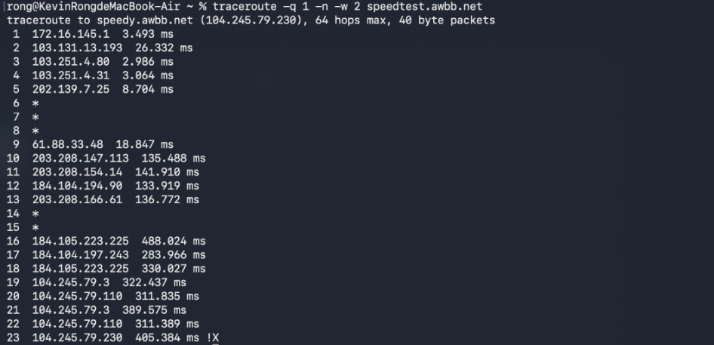
<Fig 2.1.2 traceroute command line for only one packet from my apartment to speedtest.awbb.net>
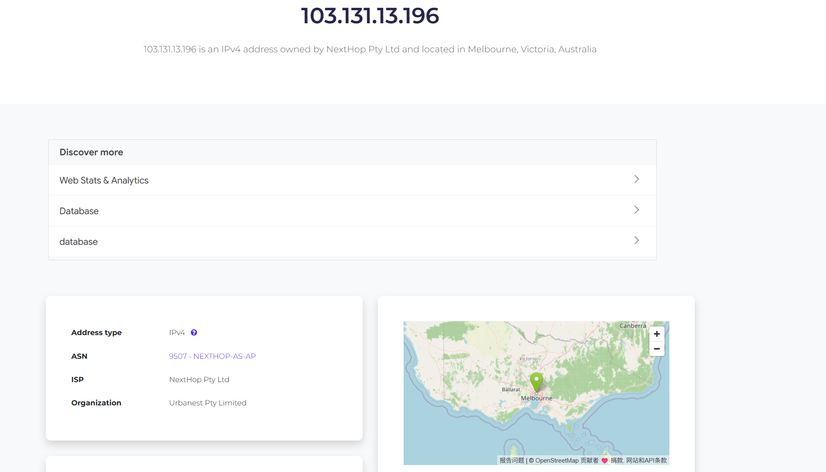
< Fig 2.1.3 IP of 2nd hop >
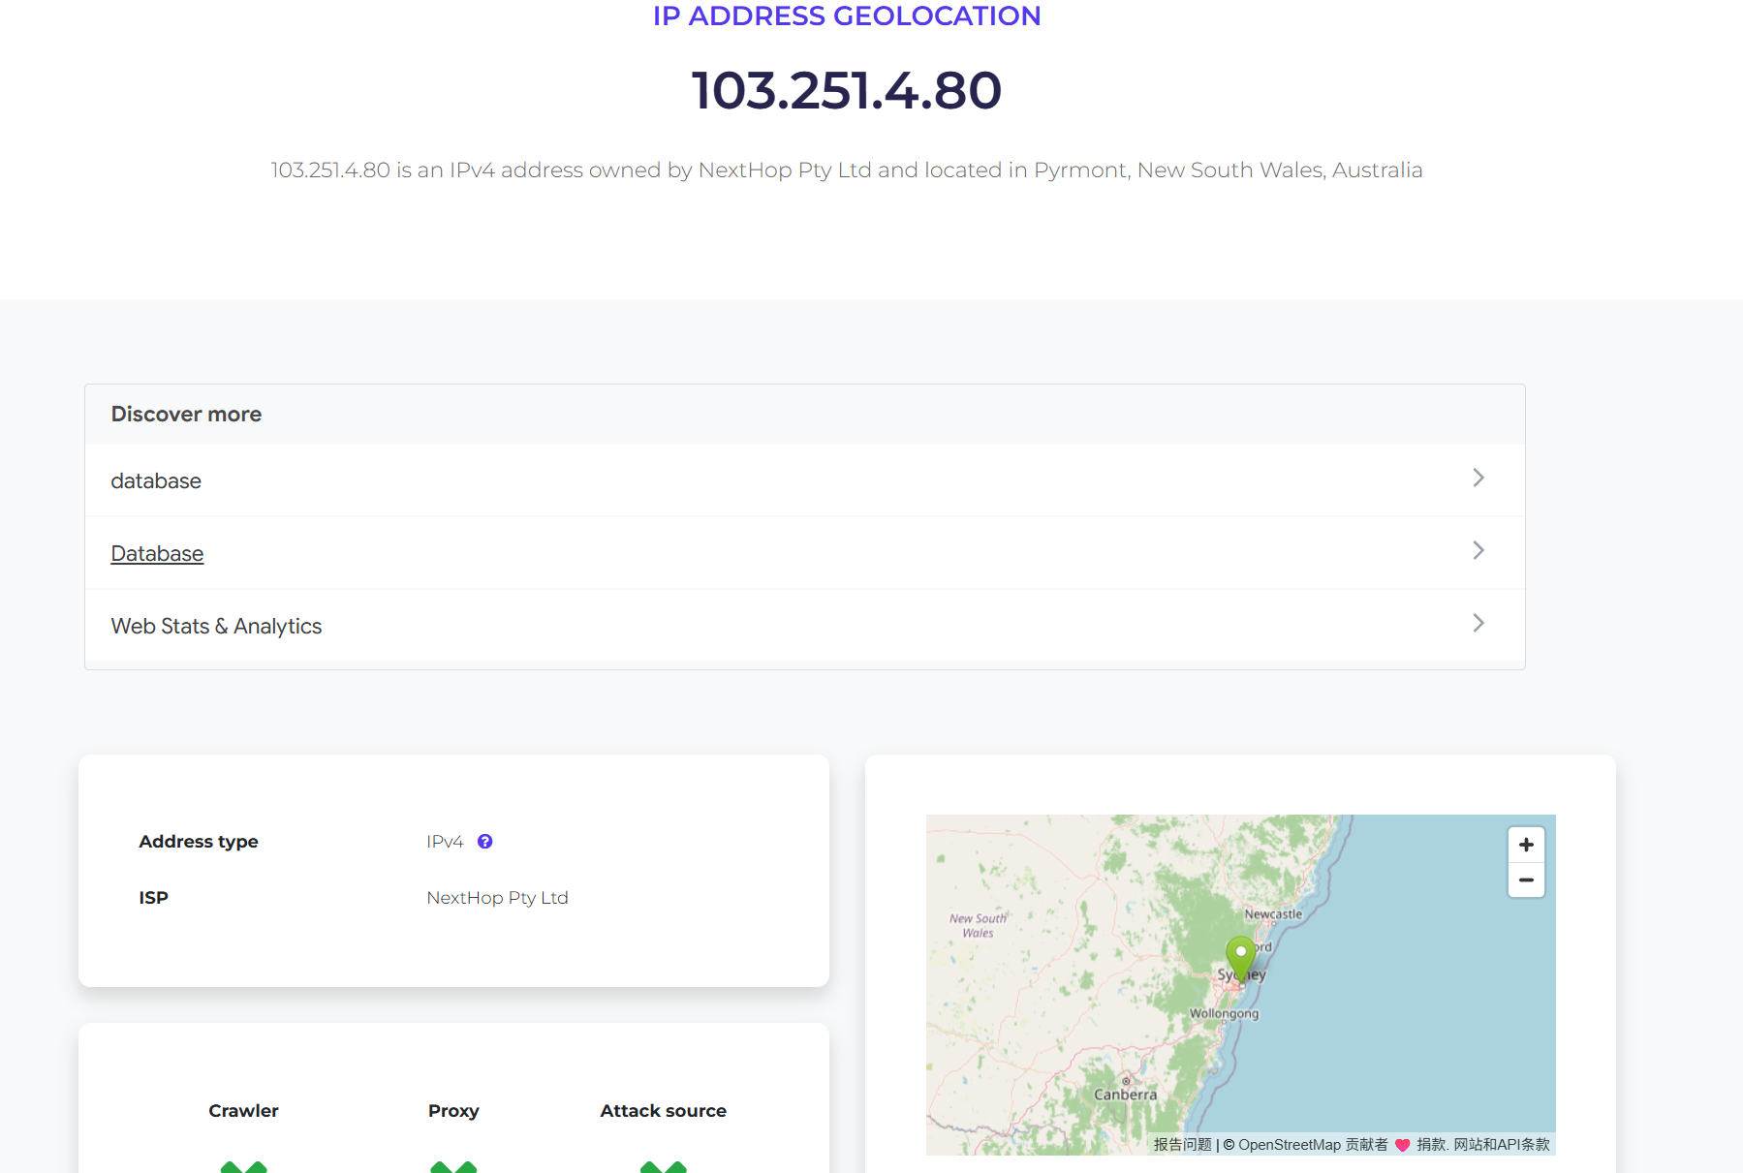
< Fig 2.1.4 IP of 3rd hop >
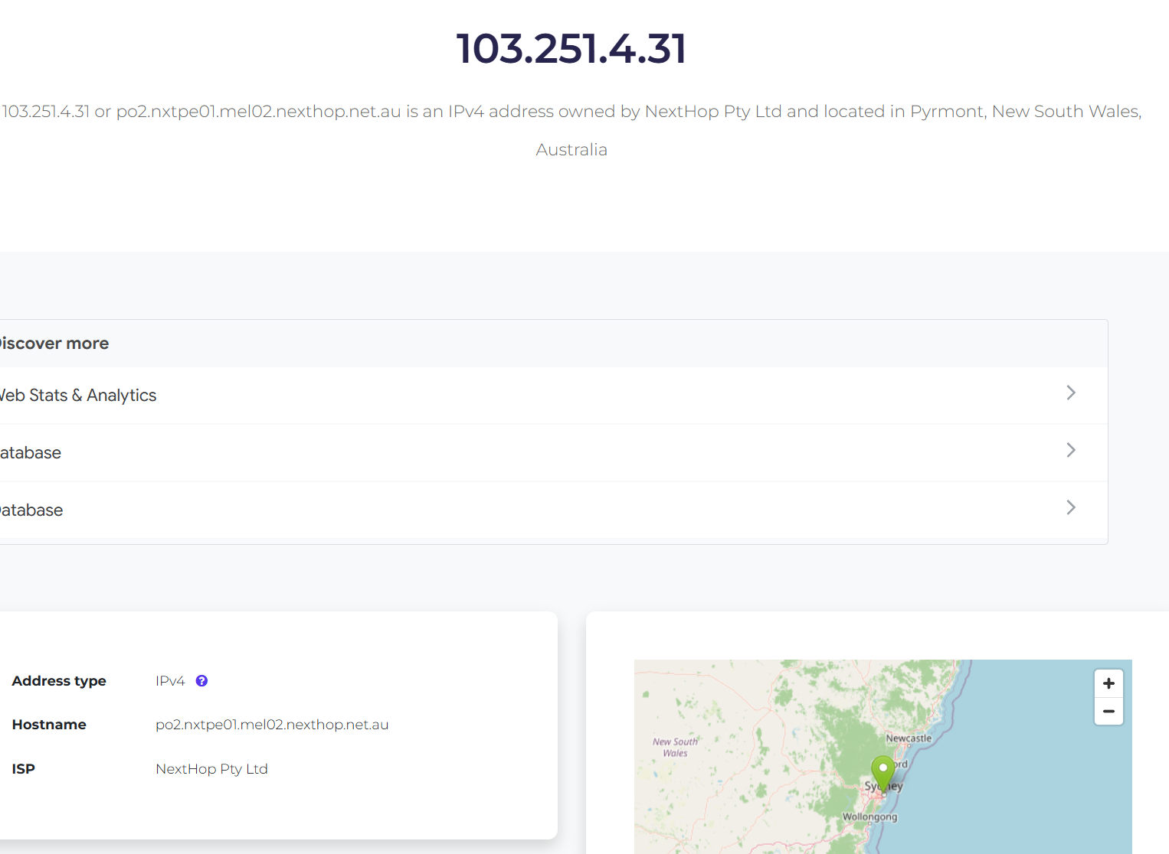
< Fig 2.1.5 IP of 4th hop >
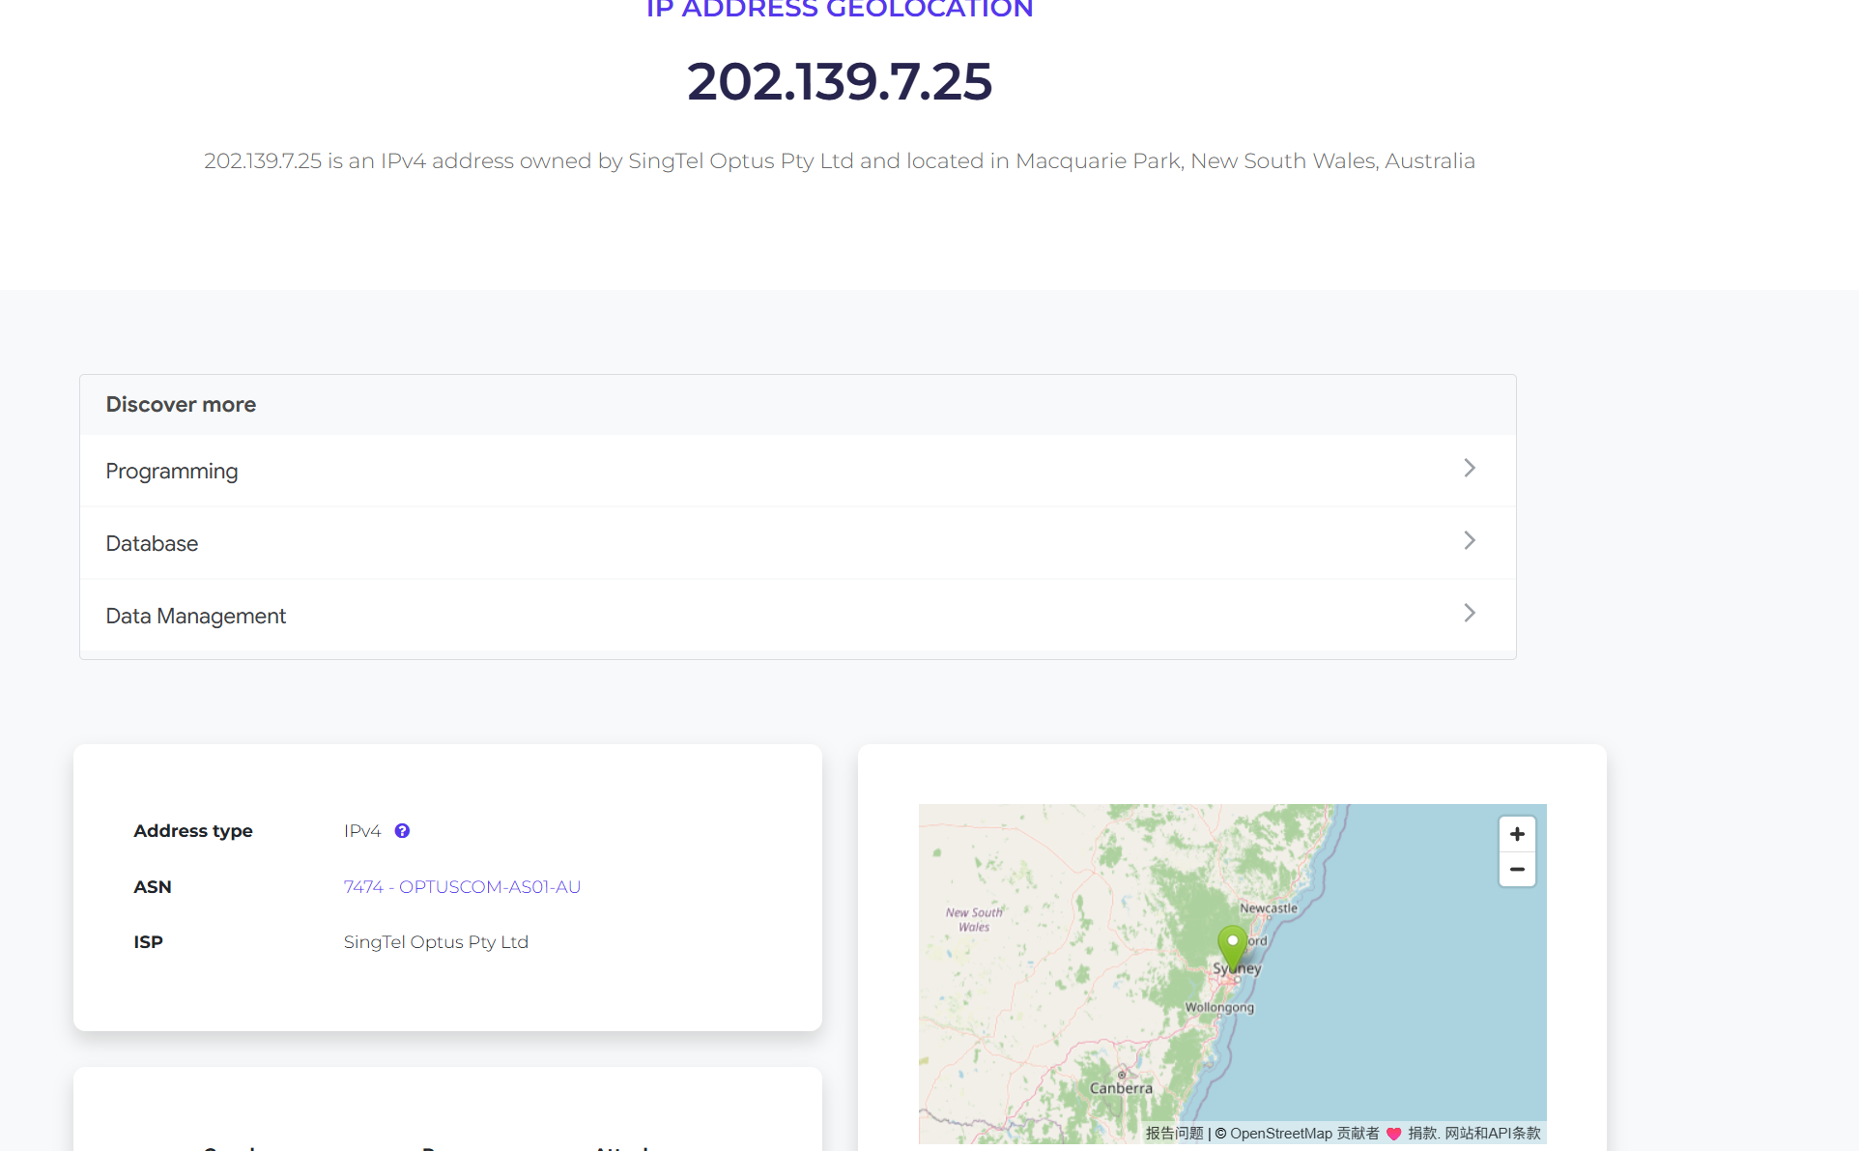
< Fig 2.1.6 IP of 5th hop >
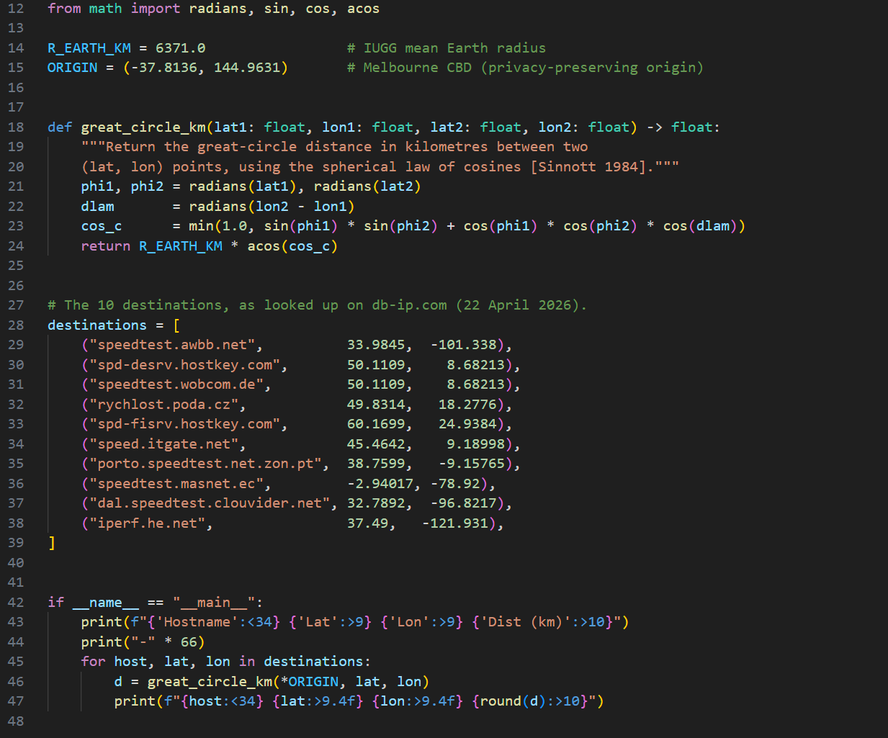
<Fig 2.2.3 Python for distance>
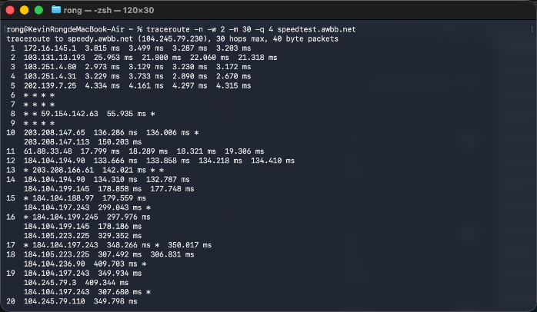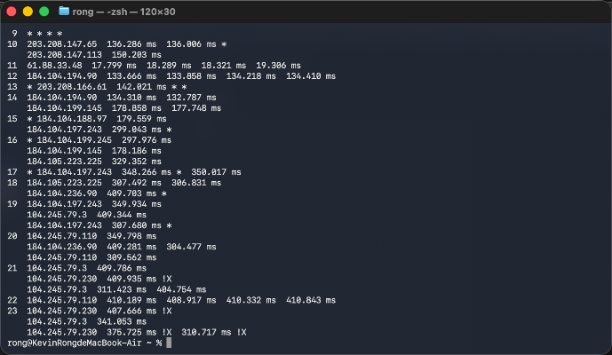
<Fig 2.2.4(a) speedtest.awbb.net> < Fig 2.2.4(b) speedtest.awbb.net>
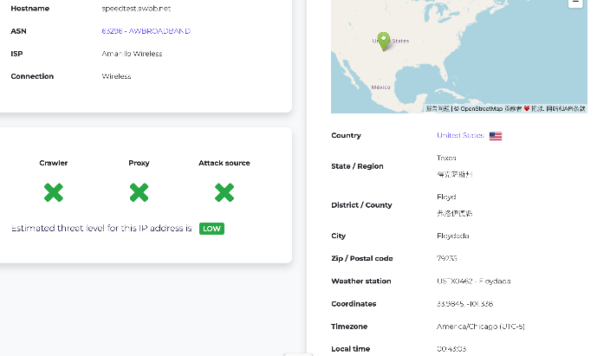
<Fig 2.2.4(c) speedtest.awbb.net>
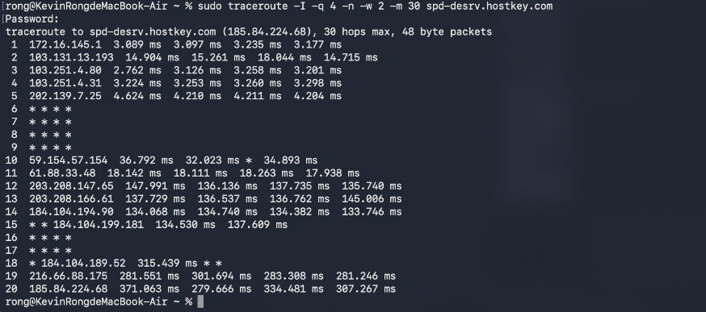
<Fig2.2.5(a) spd-desrv.hostkey.com>
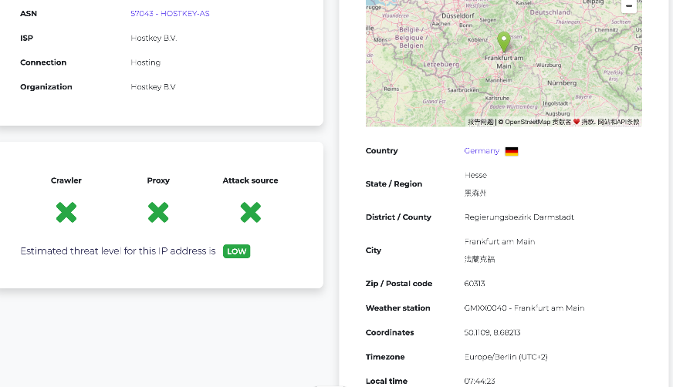
<Fig2.2.5(b) spd-desrv.hostkey.com>
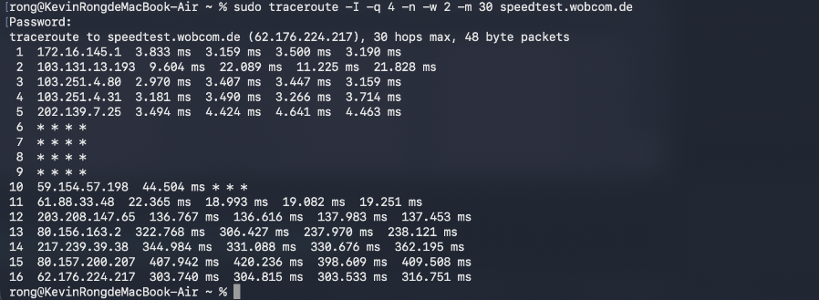
<Fig 2.2.6(a) speedtest.wobcom.de>
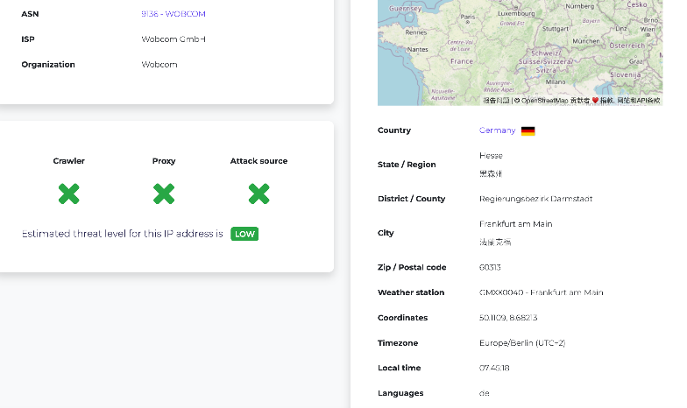
<Fig 2.2.6(b) speedtest.wobcom.de>
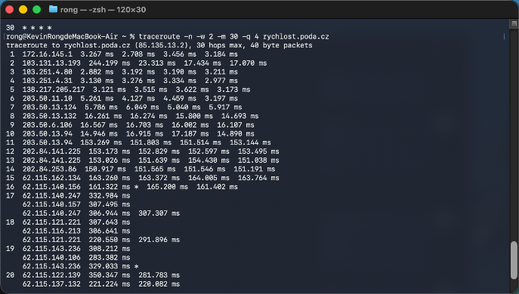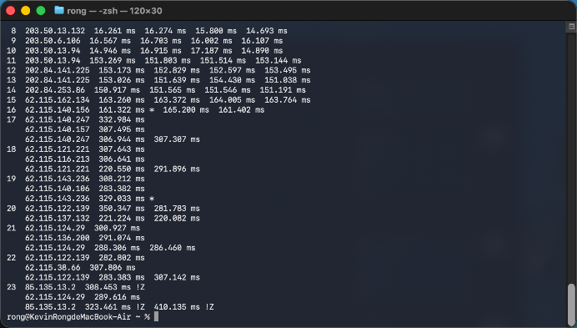
< Fig 2.2.7(a) rychlost.poda.cz > < Fig 2.2.7(b) rychlost.poda.cz >
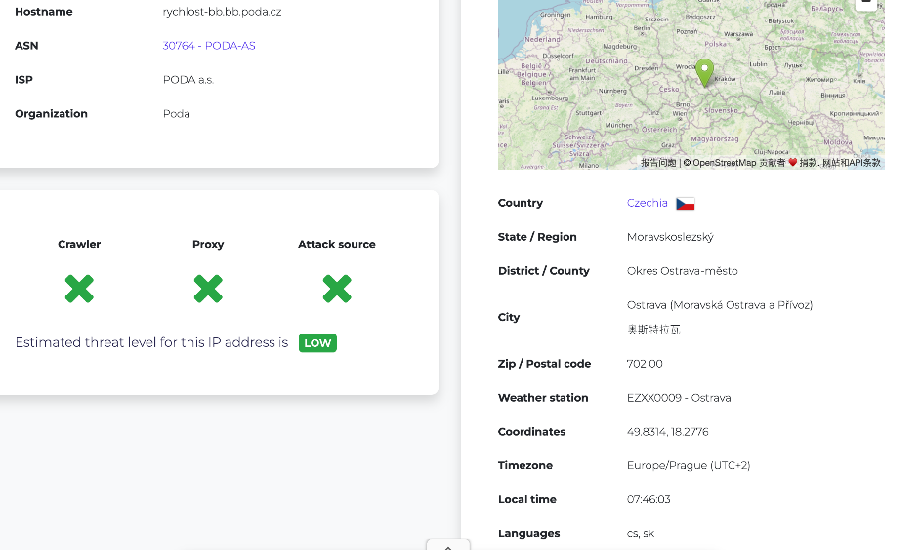
<Fig 2.2.7(c) speedtest.wobcom.de>
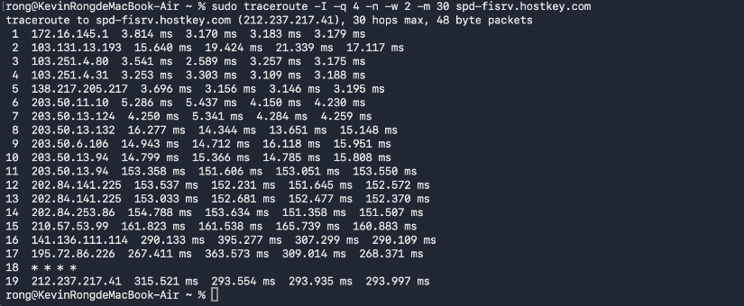
< Fig 2.2.8(a) spd-fisrv.hostkey.com >
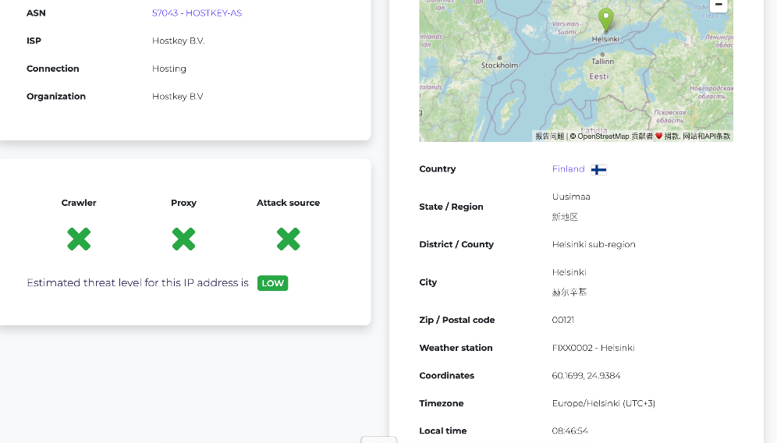
< Fig 2.2.8(b) spd-fisrv.hostkey.com >
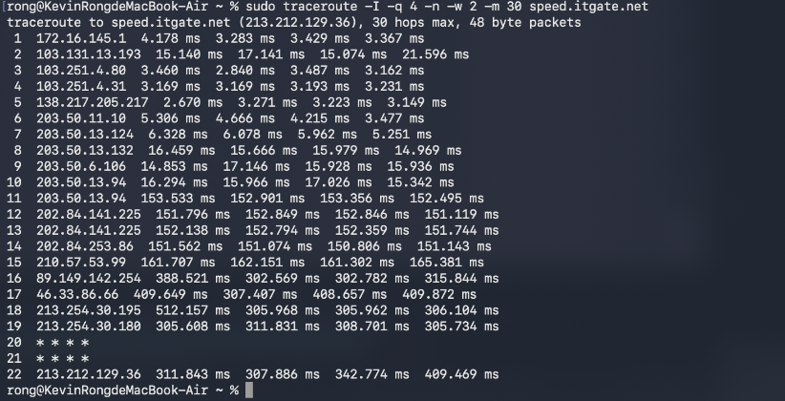
< Fig 2.2.9(a) speed.itgate.net >
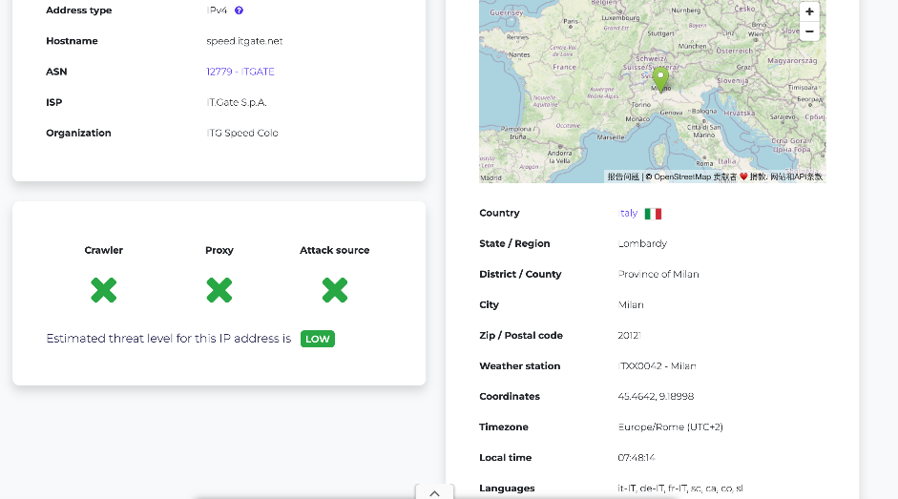
< Fig 2.2.9(b) speed.itgate.net >
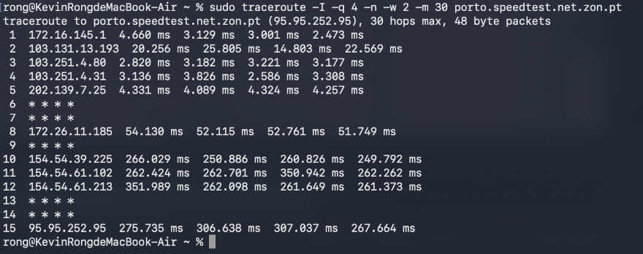
< Fig 2.2.10(a) porto.speedtest.net.zon.pt >
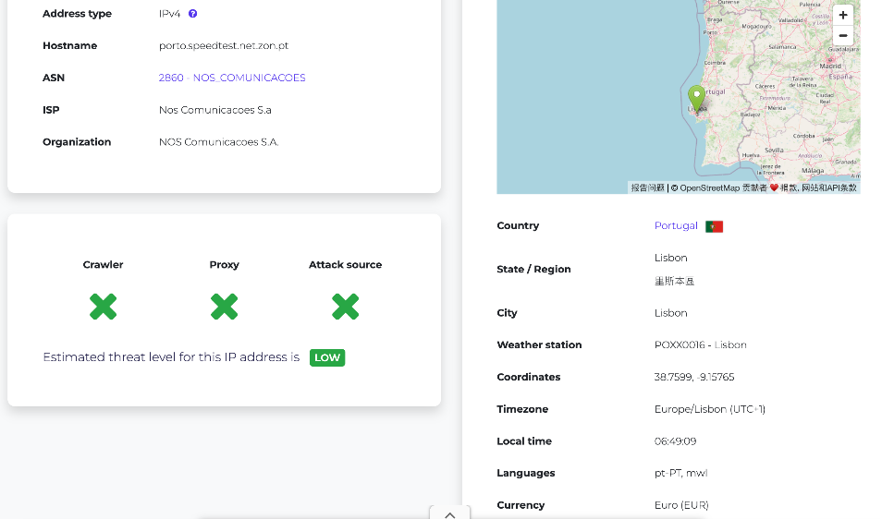
< Fig 2.2.10(b) porto.speedtest.net.zon.pt >
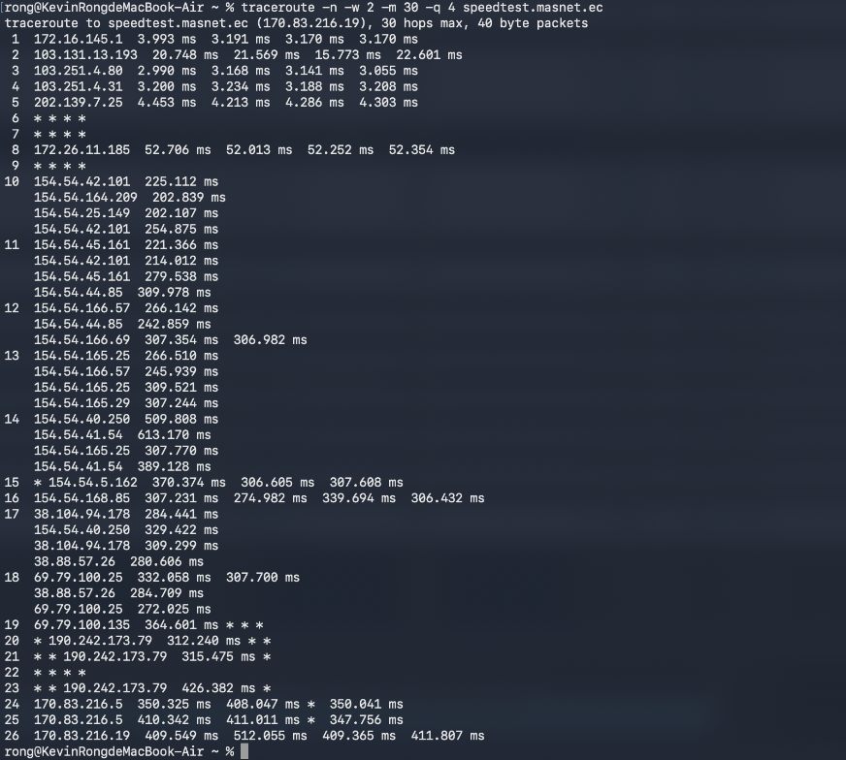
< Fig 2.2.11(a) speedtest.masnet.ec >
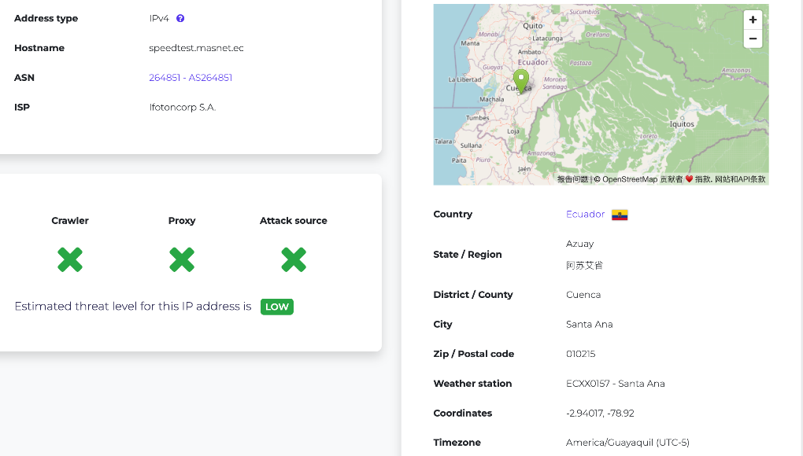
< Fig 2.2.11(b) speedtest.masnet.ec >
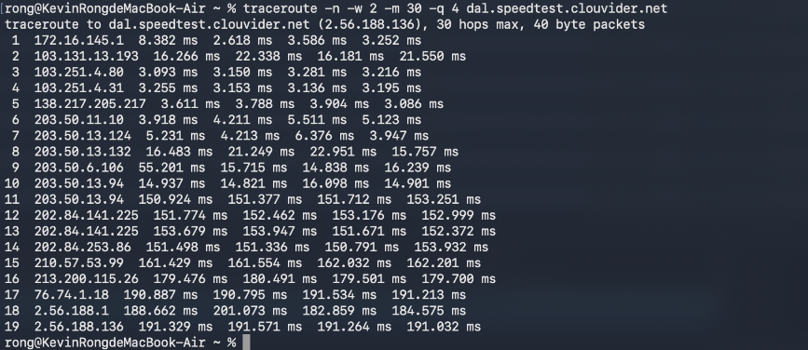
< Fig 2.2.12(a) dal.speedtest.clouvider.net >
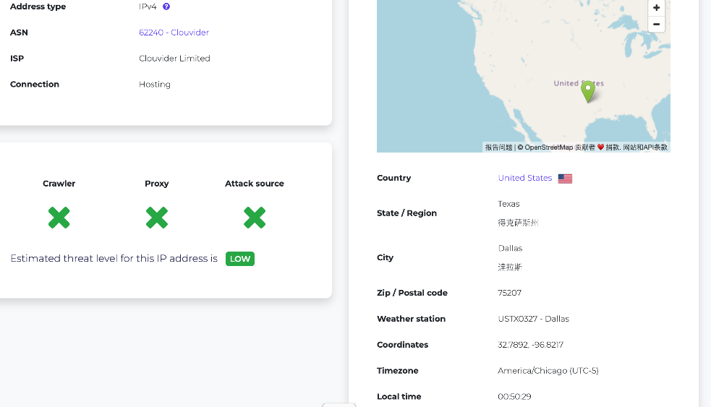
< Fig 2.2.12(b) dal.speedtest.clouvider.net >
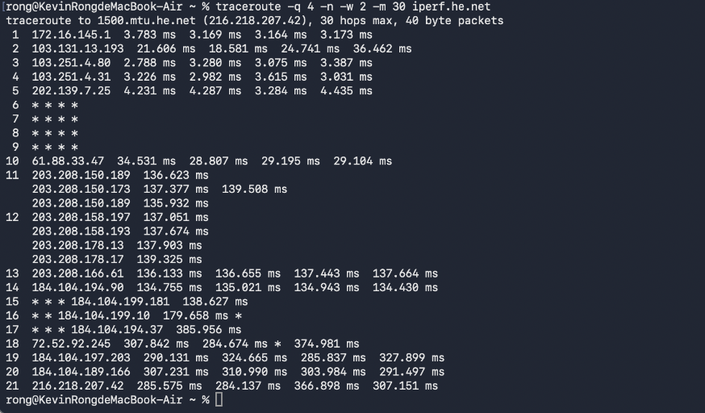
< Fig 2.2.13(a) iperf.he.net >
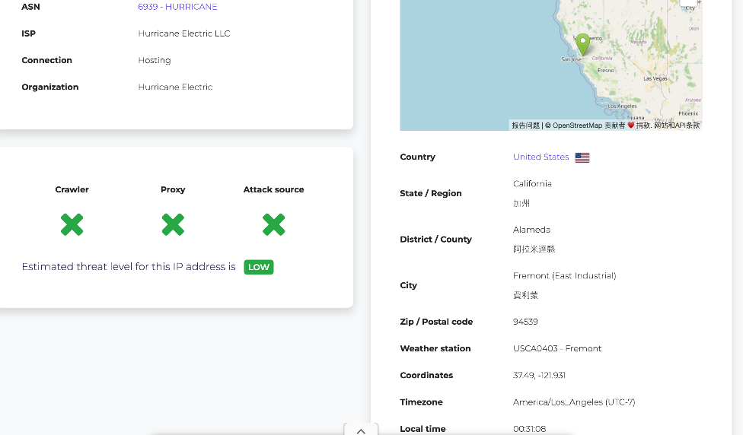
< Fig 2.2.13(b) iperf.he.net >

Section 3
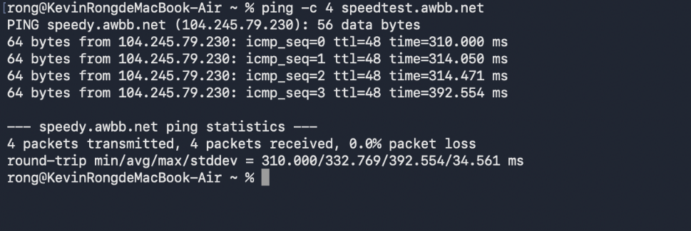
<Fig 3.1.2 ping for speedtest.awbb.net>
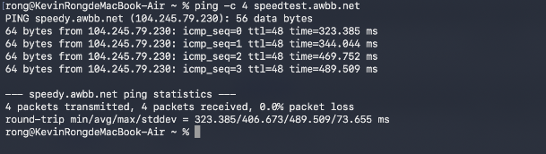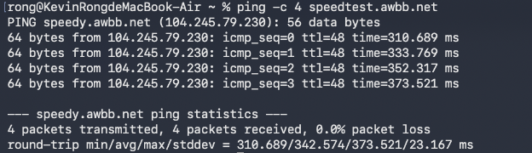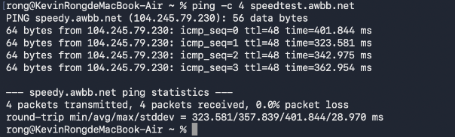
<Fig 3.2.1 3 times ping for speedtest.awbb.net>
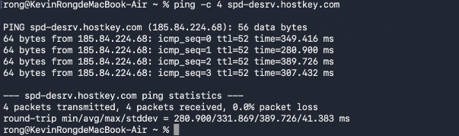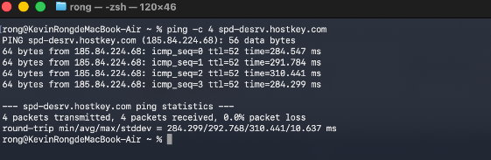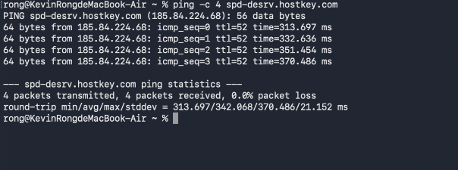
<Fig 3.2.2 3 times ping for speedtest.awbb.net>
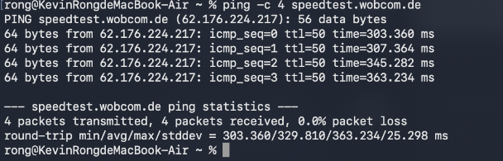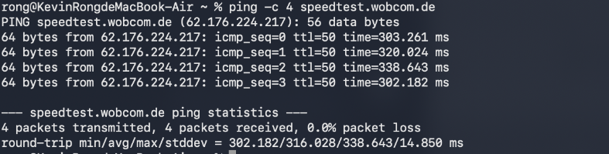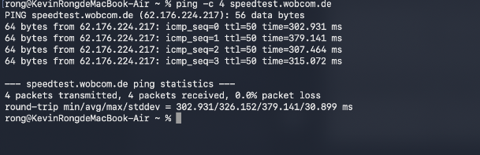
<Fig 3.2.3 3 times ping for speedtest.awbb.net>

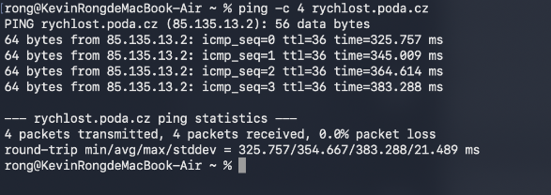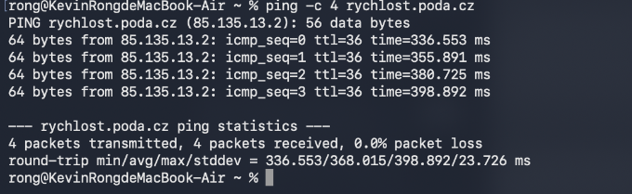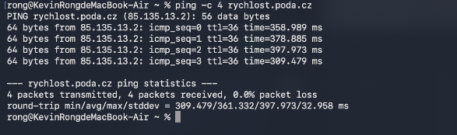
<Fig 3.2.4 3 times ping for speedtest.awbb.net>
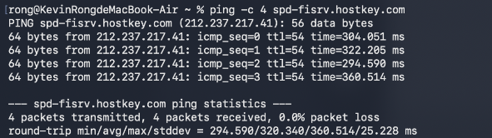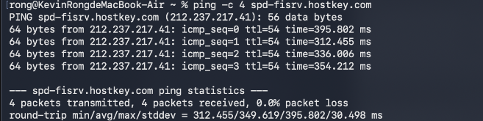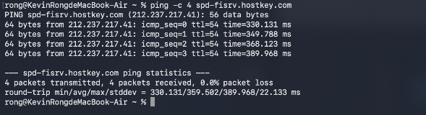
<Fig 3.2.5 3 times ping for speedtest.awbb.net>
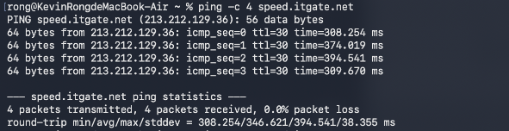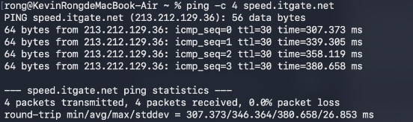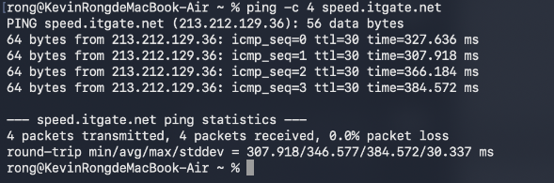
<Fig 3.2.6 3 times ping for speedtest.awbb.net>
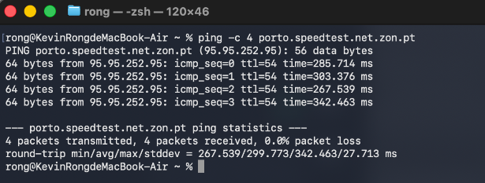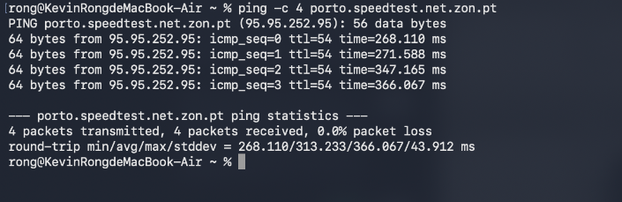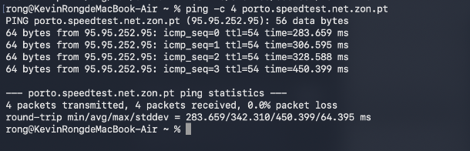
<Fig 3.2.7 3 times ping for speedtest.awbb.net>

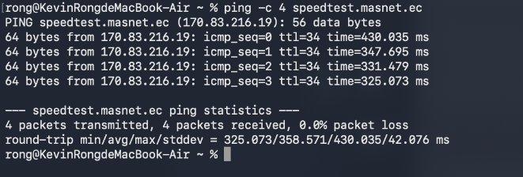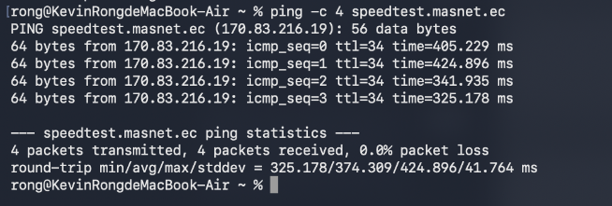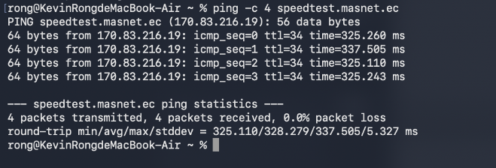
<Fig 3.2.8 3 times ping for speedtest.awbb.net>
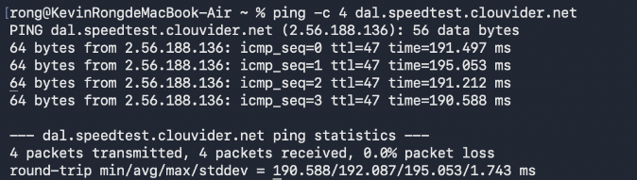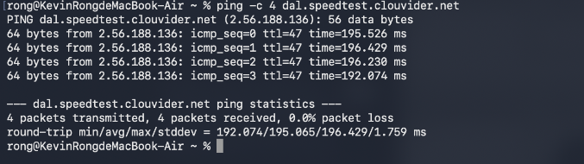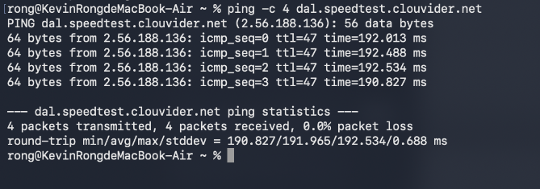
<Fig 3.2.9 3 times ping for speedtest.awbb.net>
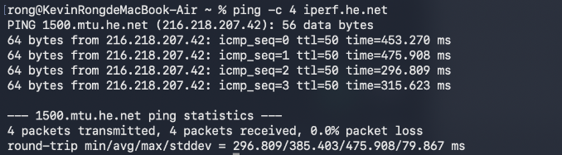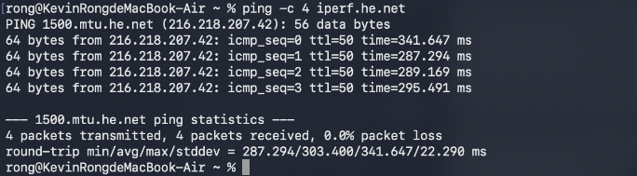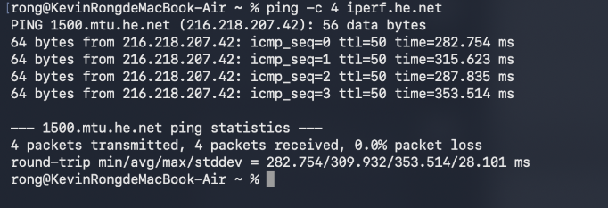
<Fig 3.2.10 3 times ping for speedtest.awbb.net>

Section 4
<Insert Images of results – screenshots of terminal/cmd>
<Insert Calculations>

